**Documentation Of DBMS Course Project**

Topic : Online shopping (E-commerce )

Number of tables :8

ER diagram:

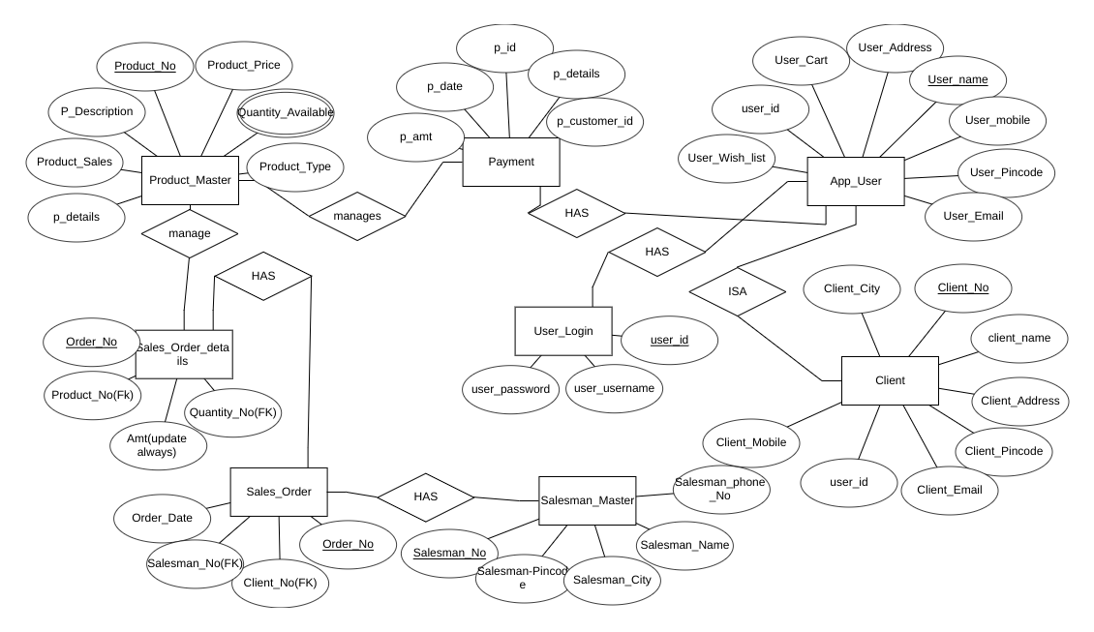

Details of tables:

1)Product_master

A.p_details -[FK]payment details,This attribute is common between payment and

product master table.

B.product_sales- Information of product sales

C.product_description -detailed information of product which are there to sale

D.product_no -[PK]product has given a unique id i.e number .user ordered some specific

product which is named by some product number

E.product_price -prices of products

F.quantity_available -multivalued attribute - this is multivalued attribute which

describes available quantities.

G.product_type -Types of product.categories like women, men,etc.

2.sales_order_details

A.order_no-[PK]user orders some specific product and it has some order number.

B.product_no- [FK]product has given a unique id i.e number .user ordered some specific

product which is named by some product number

C.amt-price of product

D.quantity_no- how many quantities are ordered by user is indicated by quantity number

3. Sales_order -

A.order_date-date on which user ordered product

B.salesman_no-[FK]salesman who will deliver order to user

C.client_no- [FK]user number,id ,etc.

D.order_no-[PK]user orders some specific product and it has some order number.

4.salesman_master

A.salesman_no-[PK]salesman unique id

B.salesman_pincode-pincode id of salesman

C.salesman_city-city of salesman

D.salesman_name-name of salesman

E.salesman_phone_no-salesman phone number

5.client-

A.client_mobile-mobile number of client

B.user_id-[FK]user id of client to log in to web/app

C.client_email-email id of client for creation of workspace for user

D.client_pincode-pincode of client,address requirement

E.client_address-address of client for delivery purpose

F.client_name-name of client

G.client_no-[PK]unique id of client which is primary key of this table

H.client_city-city of client for address purpose for delivery.

6.App_user -

A.user_wish_list-user wants to wish to buy this product

B.user_id-[FK]user id of client/user user id is necessary for log in to the web/app

C.user_cart-user added product to buy the product

D.user_address-address of user

E.user_name-name of user for log in to the app/website

F.user_mobile-mobile number of user

G.user_pincode-pincode of user for location purpose.

H.user_email-email address of user for login purpose.

7.user_log_in

A.user_password-password of user for security purpose.

B.user_username-username of user for login purpose

C.user_id-[PK]user id of user for login app/website.